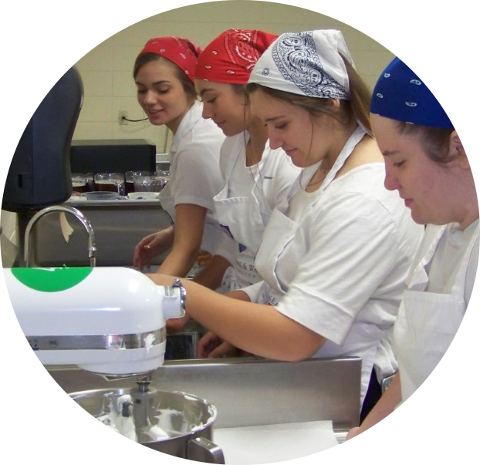
`
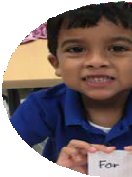
MADISON
COUNTY
SCHOOL
BOARD

2021-26
STRATEGIC PLAN

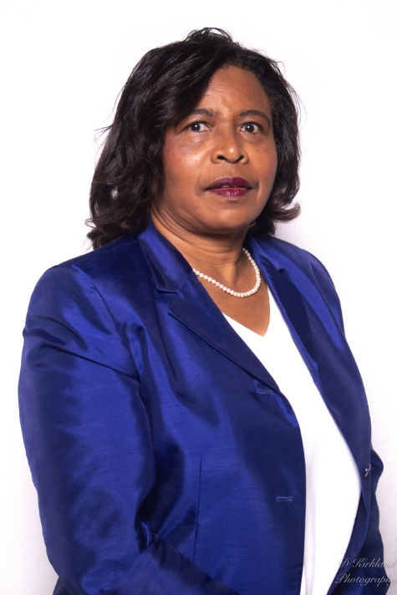

MESSAGE FROM THE
SUPERINTENDENT

Shirley Joseph
Preparing students to be College,
Career, and Life Ready

The new 2021-2026 Strategic Plan will place an emphasis on “educating all children in a safe, quality learning climate that ensures success.” The development of this 2021-2026 Strategic Plan was a collaborative process. Parents, community members, community-based organizations, and Madison County School District employees participated in multiple sessions to provide constructive, thoughtful, and valuable input.

On behalf of the District, I want to express my thanks for the numerous contributions to the development of this plan. The Strategic Plan is designed to provide a college and career pathway for every student. We will continue to work collaboratively with all Madison County families and community stakeholders to help every student achieve success.

Thank you,

Shirley Joseph
Superintendent of Schools

VISION
A school district that is community driven to educate our children to graduate with the skills reach their highest potential

MISSION
To educate all children in a safe, quality learning climate that ensures success

CORE VALUES
- Accountability – We take responsibility for our individual and collective commitments that empower our students and strengthen our community.
- Equity – We celebrate diversity and provide the necessary resources to eliminate barriers to success and foster a more equitable future for our students.
- Integrity - We foster positive relationships based on mutual respect, transparency, honesty, and consistent demonstration of actions
- Safety – Our schools are safe and secure for all students as they provide the opportunity to grow and thrive in a nurturing, supportive environment.
- Innovation – We develop all students to their highest potential to produce successful, innovative citizens and leaders.
- Collaboration – We foster collaborative teamwork, critical thinking, mastery of content, personal growth, and a school-wide learning culture among students and staff.

SCHOOL BOARD
MEMBERS

ROY TERRY
BOARD CHAIR
DISTRICT 5

STEPHANIE LUCARELLI
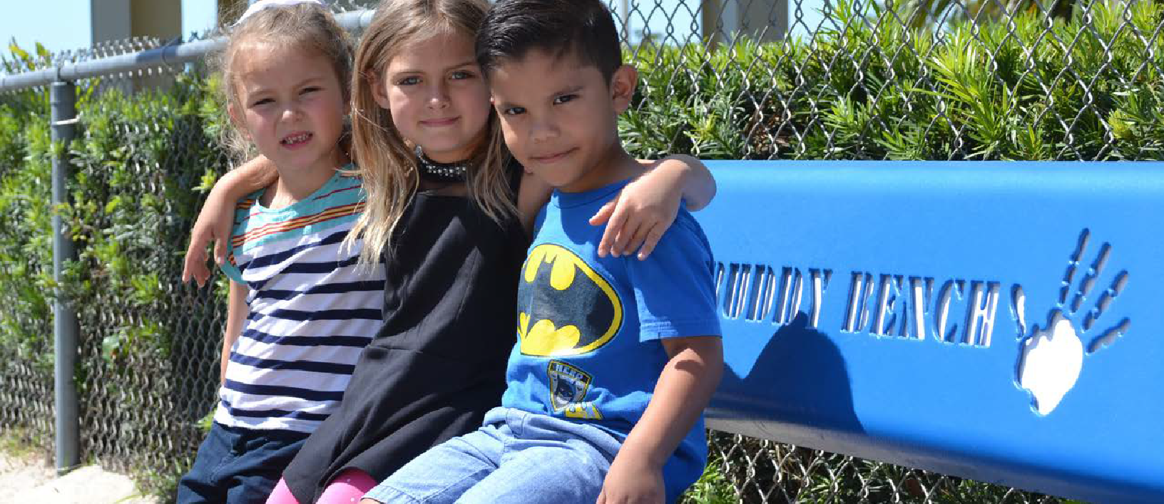
2021-2026 STRATEGIC PLAN
EXECUTIVE SUMMARY

COLLEGE, CAREER, AND LIFE READY
Madison County District Schools serves approximately 1,600 students in our traditional schools. In an effort to ensure that we are meeting the needs of our students the District put together a team of educational personnel along with business and community leaders for our strategic planning process. This group recommended focusing on 3 areas: Learning Imperatives, Leadership Imperatives, and Resource Imperatives. To guide the discussions and goals, the group continuously focused on suggestions that correlated to the superintendent’s mantra - Preparing Students to be College, Career, and Life Ready.
The group reviewed and updated the district’s vision and mission.
Vision: A school district that is community driven to educate our children to graduate with the skills to reach their highest potential
Mission: To educate children in a safe, quality learning climate that ensures success
The vision and mission serve as reminders to students, staff, parents, and community members that everyone plays a role in helping students become college, career, and life ready. The district cannot educate students in isolation, and the future of our community is dependent upon the success of all students in our district. This new Strategic Plan reflects the priorities of our district and our community.

Each imperative area is based on strategically selected Key Performance Indicators (KPIs) that would continue to positively impact student achievement. The KPI is a five year goal and is Specific, Measurable, Attainable, Realistic/Relevant, and Time-bound (SMART). Short term goals are the actions that will be taken to achieve the goals set forth in the plan and are updated annually. Three categories – Learning, Leadership, and Resources – have been created to organize the 18 Strategic Imperatives. Each Strategic Imperative has a Key Performance Indicator (KPI) which is the driving force of the plan

During the course of the 2021-2022 school year, Madison County District Schools will launch the new five year Strategic Plan to address needs facing our schools. The plan is grounded on research and best practices, including:

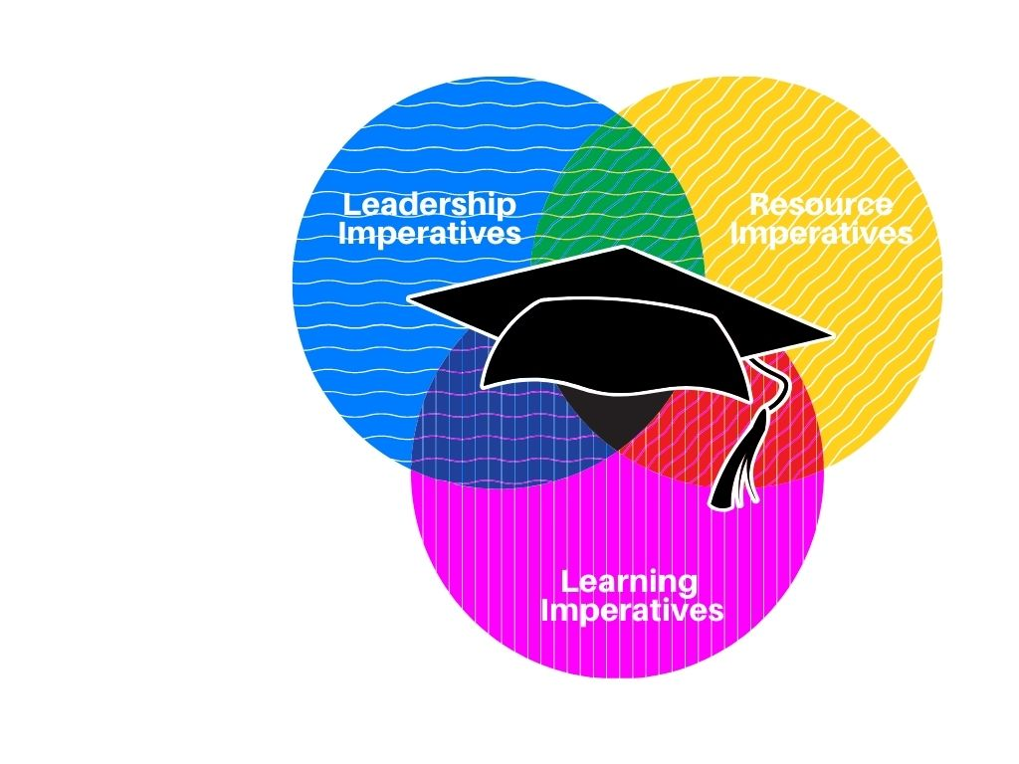
The graphic representation of the Strategic Plan shows the overlapping categories to symbolize the connectedness of the categories and how the strategic imperatives could be assigned to multiple categories supportive of college, career, and life readiness.

- Social Emotional Learning
- Parent and Family Engagement
- Safe and Secure Environment
- Fiscal Responsibility
- Resource Planning
- Professional Learning - Pathways to Leadership
- Student Leadership
- Employee Evaluation
- Cognia Accreditation
- Operational Performance Reviews
- Stakeholder Involvement

- Student Achievement
- Acceleration Rate
- Early Learning
- Teacher Retention
- Equitable Learning Opportunities
- Post-Secondary Planning
- Classroom Expenditures
RESOURCE IMPERATIVES
LEADERSHIP IMPERATIVES
LEARNING IMPERATIVES

STUDENT ACHIEVEMENT
COLLEGE, CAREER, AND LIFE READY
ACADEMICS

KEY PERFORMANCE INDICATOR (KPI)
Increase total percentage points earned for the District Grade based on FSA scores, we well as graduation and acceleration rates to 62 (A).

INCREASE ACCELERATION RATE

KEY PERFORMANCE INDICATOR (KPI)
Improve the District acceleration rate for middle and high school students to a minimum of 70 percentage points.

EARLY LEARNING

KEY PERFORMANCE INDICATOR (KPI)
At least 70% of VPK and 95% of kindergarteners will meet minimum readiness criteria for the next grade level.

TEACHER RETENTION

KEY PERFORMANCE INDICATOR (KPI)
Using district employee data, the percentage of teachers employed each year will increase by 3 percentage points per year.

2021-2022 SHORT TERM GOAL
- Increase the percentage points earned for the District Grade by five (5) from the FY19 baseline – 50 to 54

2021-2022 SHORT TERM GOALS
- Improve middle school acceleration rate by 10%, from 55% to 65%
- Improve high school acceleration rate by 2%, from 55% to 57%

2021-2022 SHORT TERM GOAL
  - A minimum of 60% of VPK students will complete VPK prepared for kindergarten based on the FLKRS Kindergarten Readiness Scores.
  - At least of 85% of kindergarteners will exit kindergarten prepared for 1st grade based on the district standards report cards.

2021-2022 SHORT TERM GOAL
  - The District will increase the percentage of teachers from 50% to 53%.

EQUITABLE LEARNING OPPORTUNITIES

KEY PERFORMANCE INDICATOR (KPI)
All subgroups will meet the minimum average proficiency rate (41%) on the state-wide assessment in reading and math.

POST-SECONDARY PLANNING

KEY PERFORMANCE INDICATOR (KPI)
The percentage of students entering post-secondary education programs will increase to 60%.

2021-2022 SHORT TERM GOAL
    - Students with disabilities will increase the average percentage of students scoring proficient on the FSA in reading from 19% to 22%.
    - Students with disabilities will increase the average percentage of students scoring proficient on the FSA in math from 24% to 27%.
    - The average percentage of black students scoring proficient on the FSA reading will increase from 23% to 26%.
    - The average percentage of black students scoring proficient on the FSA math will increase from 24% to 27%.
    - The economically disadvantaged student subgroup will increase the average proficiency score on the FSA reading from 31% to 34%.
    - The economically disadvantaged student subgroup will increase the average proficiency score on the FSA math from 34% to 37%.
    - ELL students will increase the averaged proficiency rate on the FSA reading from 11% to 17%.
    - The male subgroup will increase the average proficiency on the FSA reading from 36% to 39%.

2021-2022 SHORT TERM GOAL
- Over 58% of the seniors who graduate from Madison County High School will enter into a post-secondary education program.

CLASSROOM EXPENDITURES

KEY PERFORMANCE INDICATOR (KPI)
Over a 5 year period, the district will increase the percentage of funds spent for classrooms from 71% to 75%.

2021-2022 SHORT TERM GOAL
- The percentage of funds designated for classroom expenditures will increase 1%.

PROFESSIONAL LEARNING PATHWAYS TO LEADERSHIP
COLLEGE, CAREER, AND LIFE READY
LEADERSHIP

KEY PERFORMANCE INDICATOR (KPI)
Increase the percentage of instructional personnel who participate in leadership training opportunities by 5%

STUDENT LEADERSHIP

KEY PERFORMANCE INDICATOR (KPI)
Leadership training activities for students will increase to 5 different opportunities across grade levels.

EMPLOYEE EVALUATIONS

KEY PERFORMANCE INDICATOR (KPI)
The district performance evaluation system will be based upon a professional growth system.

ACCREDITATION

KEY PERFORMANCE INDICATOR (KPI)
Align district initiatives from the 2021-2026 Strategic Plan to support external reviews and audits including completion of Cognia documentation.

2021-2022 SHORT TERM GOAL
- The district will share and promote leadership training opportunities each semester across the district so that there will be at least a 1% increase in the number of staff who participate.

2021-2022 SHORT TERM GOAL
- The district will explore a minimum of 2 separate leadership training opportunities for each grade level.

2021-2022 SHORT TERM GOAL
- The district, in partnership with the Madison County Education Association, will develop a job specific rating system for 100% of district employees.

2021-2022 SHORT TERM GOALS
- Complete Professional Learning Protocol Review

OPERATION PERFORMANCE

KEY PERFORMANCE INDICATOR (KPI)
Demonstrate improved operational performance in Nutrition Services, Facilities Management, Transportation, and Technology by meeting or surpassing annual benchmarked metrics based upon National Performance Measurements

STAKEHOLDER INVOLVEMENT

KEY PERFORMANCE INDICATOR (KPI)
The District will provide stakeholder activities at minimum of 2 times per year.

2020-2021 SHORT TERM GOALS
  - Establish and analyze baseline data for Nutrition Services
  - Establish and analyze baseline data for Facilities Management
  - Establish and analyze baseline data for Transportation Services
  - Establish and analyze baseline data for Technology

2021-2022 SHORT TERM GOAL
  - The District will host a Stakeholder Awareness Event at the beginning of the year.

COLLEGE, CAREER, AND LIFE READY
RESOURCES

SOCIAL EMOTIONAL LEARNING

KEY PERFORMANCE INDICATOR (KPI)
Increase percentage of students in attendance 90% or more by 10% through Social Emotional Learning (SEL) and mental wellness initiatives

2021-2022 SHORT TERM GOAL
- Strengthen awareness and importance of Social Emotional Learning (SEL) with instructional and non-instructional staff,
and parents with at least one (1) school outreach activity twice during the school year
- Increase percentage of students in attendance 90% or more by 2% through Social Emotional Learning (SEL) and mental wellness initiatives

PARENT AND FAMILY ENGAGEMENT

KEY PERFORMANCE INDICATOR (KPI)
Increase the percentage of parents who participate in annual parent/family engagement activities per school

2021-2022 SHORT TERM GOAL
  - Set a baseline based on participation rates for the 20-21 school year.
  - Enhance the capacity of technology to expand online information sharing.
  - Increase the number of parent training opportunities for school communication and online programs to 2 per year.

SAFE AND SECURE ENVIRONMENT

KEY PERFORMANCE INDICATOR (KPI)
Conduct five (5) safety and security trainings for staff and students

2021-2022 SHORT TERM GOAL
- Add two (2) additional safety trainings to enhance our safety plan
- Train teachers on developing emotionally safe learning environments in their classroom yearly.

FISCAL RESPONSIBILITY

KEY PERFORMANCE INDICATOR (KPI)
Maintain a 5% District Strategic Reserve Fund Balance based upon a percentage of General Fund Revenue while raising the minimum pay for non-instructional employees to $15 per hour by 2026.

2021-2022 SHORT TERM GOAL
  - Prioritize and fund Strategic Reserve at 5% of General Fund Revenues
  - Increase minimum wage for non-instructional employees to $10 per hour.

TECHNOLOGY PLANNING

KEY PERFORMANCE INDICATOR (KPI)
Increase the accessibility to classroom technology for students and teachers.

2021-2022 SHORT TERM GOAL
  - Develop a technology plan for the next 5 years
  - Provide regular training for staff and students on district technology

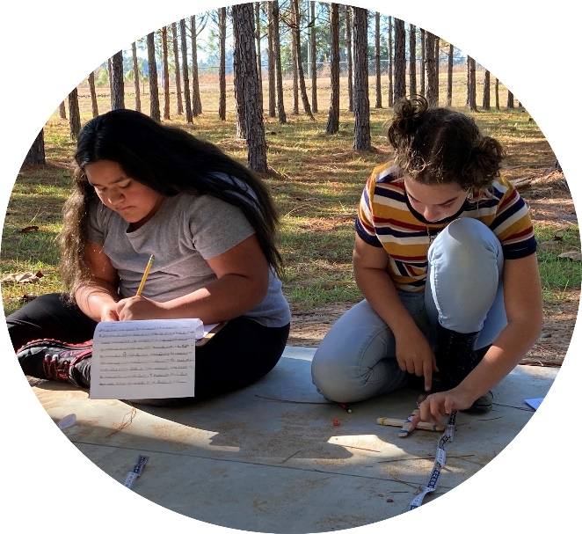
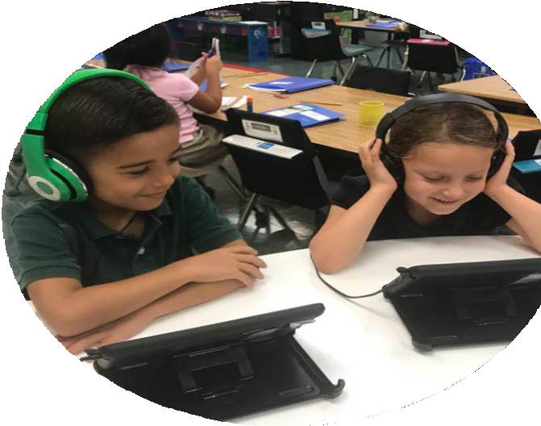
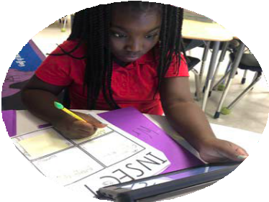

Visit us online at:
www.mcsbfl.us

Shirley Joseph
Superintendent

District School Board of Madison County
Bart Alford, Chair
Susie Williamson, Vice Chair
Carol Gibson, Member Frankie Carroll, Member
Suretta Bell, Member

210 NE Duval Ave. | Madison, Florida 32340
p: 850.973.5022 | f: 850.973.5027

